Hesperia National Little League
A chartered program of Little League Baseball, Inc.

Safety Manual
2023
Updated 11/16/2022

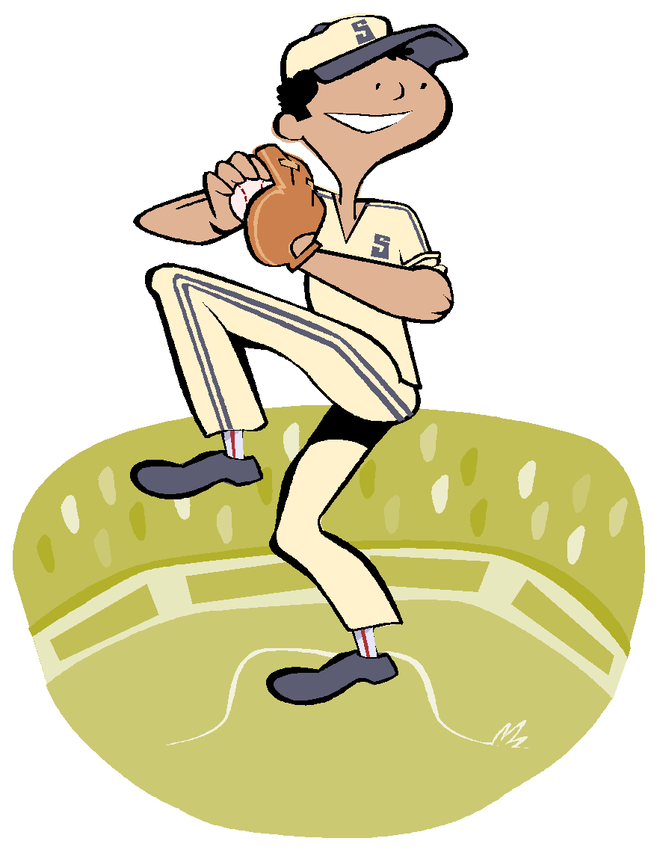

Be Smart – Be Safe – Have Fun

Important Phone Numbers

Safety Officer (Bernice Pond) ………............………… 310-291-0942

Williamsport Insurance Claim Office …………………. (570) 327-1674

EMERGENCY MEDICAL CARE ………………………… 9-1-1

POLICE:
EMERGENCY ……………………………………………… 9-1-1

Non-Emergency …………………………………………... (760) 245-4211

CITY WORKS:

Animal Control ……………………………………………. (760) 947-1700
Public Works ………………………………………………. (760) 947-1411

HOSPITALS:
Desert Valley Hospital ……………………………………. (760) 241-8000
16850 Bear Valley Rd, Victorville, CA

Victor Valley Global Medical Center……………………. (760) 245-8691
15248 11th St, Victorville, CA

St. Mary Medical Center ………………………………. (760) 242-2311
18300 US Highway 18, Apple Valley, CA

HNLL Safety Program Mission Statement

Hesperia National Little League
Is a Non-Profit Organization
Run By Volunteers
Who’s Mission
Is To Provide an Opportunity
For Our Community’s Children
To Learn the Game of Baseball & Softball
In A Safe and Friendly Environment

HNLL Code of Conduct

LITTLE LEAGUE IS A PROGRAM OF SERVICES TO OUR YOUTH

Too often parents and spectators forget that the managers and coaches are volunteers and that the players are only children.

- I (and my guests) will remember that children participate to have fun, and that the game is for the youth, not the adults.
- I (and my guests) will be a positive role model for any child and encourage good sportsmanship.
- I (and my guests) will show respect and courtesy and demonstrate positive support for all players, coaches, umpires, and League Representatives.
- I (and my guests) will ensure that all players, coaches, umpires, and League Representatives are treated with respect.
- I (and my guests) will not encourage in any kind of unsportsmanlike conduct, such as booing, taunting, refusing to shake hands, or using profane language or gestures.
- I (and my guest) will teach all children that doing one’s best is more important than winning.
- I (parent) will refrain from coaching any player during a game or practice unless I am an official coach of the team.
- I (and my guests) will not threaten anyone with physical violence, nor push, shove, or grab any individual.
- I (and my guests) will not smoke at any League Ball Fields or Parking lots, pursuant to California State Law.

ONCE THE GAME STARTS
- All coaches will remain in the dugout at all times, except when coaching a base, or when time out is requested and granted.
- I (manager) am responsible for ensuring that there are only three (3) rostered official coaches in the dugout during the game.
- Make sure that you and your team are playing within the rules of Little League Baseball and Local League Ground Rules.

The action of a manager or a coach can often be the determining factor whether a child has a good Little League experience.

HNLL Safety Code
“Safety is EVERYONE’S Responsibility!”

The Board of Directors of Hesperia National Little League has mandated the following Safety Code. All managers and coaches will read this Safety Code and then should read it to the players on their team.

- Responsibility for safety procedures belongs to every adult member of Hesperia National Little League.
- Each player, manager, designated coach, umpire, team safety officer shall use proper reasoning and care to prevent injury to him/herself and to others.
- Only league approved managers and/or coaches are allowed to practice teams.
- Only league-approved mangers and/or coaches will supervise batting Cages.
- Arrangement should be made in advance of all games and practices for emergency medical services.
- Managers, designated coaches and umpires will have mandatory training in First Aid.
- First-aid kits are issued to each team manager during the pre-season and additional kits will be located at each concession stand.
- No games or practices will be held when weather or field conditions are poor, particularly when lighting is inadequate.
- Play area will be inspected before games and practices for holes, damage, stones, glass and other foreign objects with the observance of the Safety Officer and Facilities Director.
- Team equipment should be stored within the team dugout or behind screens, and not within the area defined by the umpires as “in play”.
- Only players, managers, coaches and umpires are permitted on the playing field or in the dugout during games and practice sessions.
- Responsibility for keeping bats and loose equipment off the field of play should be that of a player assigned for this purpose or the team’s manager and designated coaches.
- During practice and games, all players should be alert and watching the batter on each pitch.
- During warm-up drills, players should be spaced so that no one is endangered by wild throws or missed catches.

- All pre-game warm-ups should be performed within the confines of the playing field and not within areas that are frequented by, and thus endangering spectators, (i.e., playing catch, pepper, swinging bats etc.).
- Equipment should be inspected regularly for the condition of the equipment as well as for proper fit.
- Batters must wear Little League approved protective helmets that bear the NOCSAE seal during batting practice and games.
- Except when a runner is returning to a base, headfirst, slides are not permitted (Majors and Below).
- During sliding practice, bases should not be strapped down or anchored.
- At no time should “horse play” be permitted on the playing field.
- On-deck batters are not permitted (Majors and Below).
- Managers will only use the official Little League balls supplied by HNLL.
- All male players will wear athletic supporters or cups during games. Catchers must wear a cup. Managers should encourage that cups be worn at practices too.
- Male catchers must wear the metal, fiber or plastic type cup and a long-model chest protector (Juniors and Above may wear short model chest protector).
- Female catchers must wear long or short model chest protectors.
- All catchers must wear chest protectors with neck collar, throat guard, shin guards and catcher’s helmet, all of which must meet Little League specifications and standards.
- All catchers must wear a mask, “dangling” type throat protector and catcher’s helmet during practice, pitcher warm-up, and games. Note: Skullcaps are not permitted.
- Shoes with metal spikes or cleats are not permitted. Shoes with molded cleats are permissible (Junior/Senior/Big League Baseball/Softball may wear metal cleats).
- Players will not wear watches, rings, pins, jewelry or other metallic items during practices or games. (Exception: Jewelry that alerts medical personnel to a specific condition is permissible and this must be taped in place.).
- No food or drink, at any time, in the dugouts. (Exception: bottled water, Gatorade and water from drinking fountains).
- Catchers must wear a catcher’s mitt (not a first baseman’s mitt or fielder’s glove) of any shape, size or weight consistent with protecting the hand (Baseball Only).

- Catchers may not catch, whether warming up a pitcher, in practices, or games without wearing full catcher’s gear and an athletic cup as described above.
- Managers will never leave an unattended child at a practice or game.
- No children under league age 16 are permitted in the Concession Stands.
- Never hesitate to report any present or potential safety hazard to the HNLL Safety Officer immediately.
- Make arrangements to have a cellular phone available when a game or practice is at a facility that does not have public phones.
- No alcohol or drugs allowed on the premises at any time.
- No medication will be taken at the facility unless administered directly by the child’s parent. This includes aspirin and Tylenol.
- No playing in the parking lots at any time.
- No playing in construction areas at any time. This includes the sand bins.
- No smoking within twenty feet of the dugouts and concession stands.
- No swinging bats or throwing baseballs at any time within the walkways and common areas of the complex and will be enforced by the Board of Directors and all volunteers.
- Observe all posted signs.
- Players and spectators should be alert at all times for foul balls and errant throws.

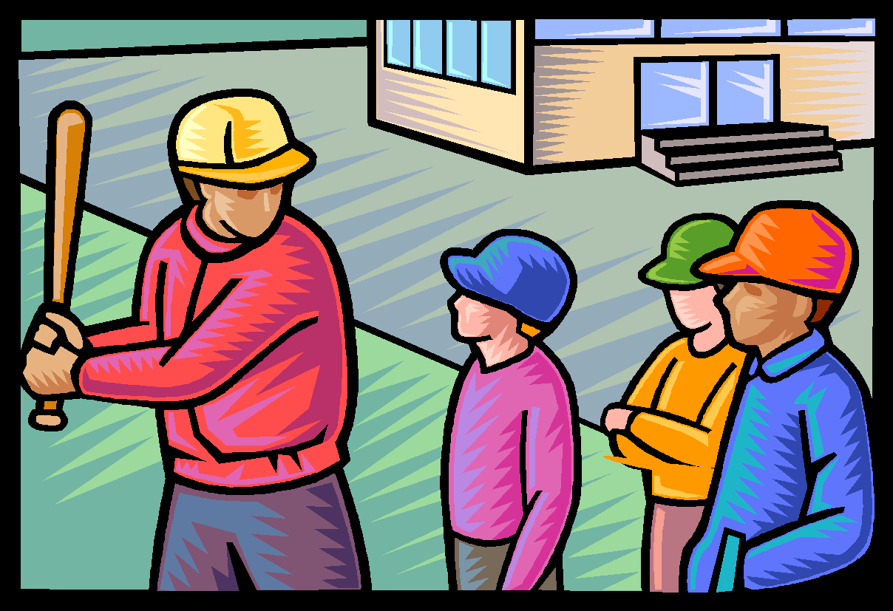

League Safety Responsibilities

THE PRESIDENT:

The PRESIDENT of HNLL is responsible for ensuring that the policies and regulations of the HNLL Safety Officers are carried out by the entire membership to the best of their ability.
Submit league player Roster data as well as the managers and coaches data.to Little League Headquarters by the due date.

THE SAFETY OFFICER:

The main responsibility of the HNLL Safety Officer is to develop and implement the League’s safety program.

The HNLL Safety Officer is the link between the Board of Directors of Hesperia National Little League and its managers, coaches, umpires, team safety officers, players, spectators, and any other third parties on the complex in regard to safety matters, rules and regulations.

The HNLL Safety Officer’s responsibilities include:
- Coordinating the individual Team Managers in order to provide the safest environment possible for all.
- Submit league player registration data or player roster data and coach and manager data via Little League Data Center
- Assisting parents and individuals with insurance claims and will act as the liaison between the insurance company and the parents and individuals.
- Explaining insurance benefits to claimants and assisting them with filing the correct paperwork.
- Ensuring that each team receives its Safety Manual and its First-Aid Kit at the beginning of the season.
- Installing First-Aid Kits in all concession stands and restocking the kits as needed.
- Make Little League’s “no tolerance with child abuse” clear to all.
- Inspecting concession stands and checking fire extinguishers.
- Instructing concession stand workers on the use of fire extinguishers.
- Checking fields with the Field Managers and listing areas needing attention.
- Scheduling a First-Aid Clinic and CPR training class for all managers, designated coaches, umpires, player agents and team safety officers during the pre-season.
- Creating and maintaining all signs on the HNLL complex including No Parking signs, No Smoking signs, cautionary signs etc...
- Acting immediately in resolving unsafe or hazardous conditions once a situation has been brought to his/her attention.
- Making spot checks at practices and games to make sure all managers have their First-Aid Kits and Safety Manuals. The Safety Officer and Board of Directors will monitor these regulations and notify the Board of any teams violating this regulation.
- Tracking all injuries and near misses in order to identify injury trends.
- Visiting other leagues to allow a fresh perspective on safety.
- Submit a qualified safety plan registration form with the ASAP plan by February 1 of each year.
- Making sure that safety is a monthly Board Meeting topic and allowing experienced people to share ideas on improving safety.

HNLL MEMBERS:

The HNLL Members will adhere to and carry out the policies as set forth in this safety manual.

MANAGERS AND COACHES:

The Manager is a person appointed by the president of HNLL to be responsible for the team’s actions on the field, and to represent the team in communications with the umpire and the opposing team.
- The Manager shall always be responsible for the team’s conduct, observance of the official rules and deference to the umpires.
- The Manager is also responsible for the safety of his players. He/She is also ultimately responsible for the actions of designated coaches.
- If a Manager leaves the field, that Manager shall designate a Coach as a substitute and such Substitute Manager shall have the duties, rights, and responsibilities of the Manager.

PRE-SEASON:

Managers will:
- Take possession of this Safety Manual and the First-Aid Kit supplied by HNLL.
- Cover the basics of safe play with his/her team before starting the first practice.
- Teach players the fundamentals of the game while advocating safety.
- Teach players how to slide before the season starts. A board representative will be available to teach these fundamentals if the Manager or designated coaches do not know them.
- Notify parents that if a child is injured or ill, he or she cannot return to practice unless they have a note from their doctor. This medical release protects you if that child should become further injured or ill. THERE ARE NO EXCEPTIONS TO THIS RULE!
- Tell parents to bring sunscreen for themselves and their child.

SEASON PLAY:

Managers will:
- Make sure that telephone access is available at all activities including practices. It is suggested that a cellular phone always be on hand.
- Not expect more from their players than what the players are capable of.
- Teach the fundamentals of the game to players.
  - Catching fly balls.
  - Sliding correctly.
  - Proper fielding of ground balls; and,
  - Simple pitching motion for balance.
- Be open to ideas, suggestions or help.
- Enforce that prevention is the key to reducing accidents to a minimum.
- Have players wear sliding pads if they have cuts or scrapes on their legs.
- Always have First-Aid Kit and Safety Manual on hand.
- Use common sense.

PRE-GAME AND PRACTICE:

Managers will:
- Make sure that players are healthy, rested and alert.
- Make sure that players returning from being injured have a medical release form signed by their doctor. Otherwise, they can’t play.
- Make sure players are wearing the proper uniform and catchers are wearing a cup.
- Make sure that the equipment is in good working order and is safe.
- Agree with the opposing manager on the fitness of the playing field. In the event that the two managers cannot agree, the President or a duly delegated representative shall make the determination.
- Enforce the rule that no bats and balls are permitted on the field until all players have done their proper stretching. (See Conditioning Section)
- Calf muscles
- Hamstrings
- Quadriceps
- Groin
- Back
- Shoulders
- Elbow/forearm
- Arm shake out
- Neck
- Then have players do a light jog around the field before starting to throw warm-ups that should follow this order.
  - Light tosses short distance.
  - Light tosses medium distance.
  - Light tosses large distance.
  - Medium tosses medium distance.
  - Regular tosses medium distance.
  - Field ground balls.
  - Field pop flies

DURING THE GAME:

Managers will:
- Make sure that players carry all gloves and other equipment off the field and to the dugout when their team is up at bat. No equipment shall be left lying on the field, either in fair or foul territory.
- Keep player’s alert.
- Maintain discipline at all times.
- Be organized.
- Keep players and substitutes sitting on the team’s bench or in the dugout unless participating in the game or preparing to enter the game.
- Make sure catchers are wearing the proper equipment.
- Encourage everyone to think Safety First.
- Observe the “no on-deck” rule for batters and keep players behind the screens at all times. No player should handle a bat in the dugouts at any time.
- Keep players off fences.
- Get players to drink often so they do not dehydrate.
- Not play children that are ill or injured.
- Attend to children that become injured in a game.
- Not lose focus by engaging in conversation with parents and passersby.

POST GAME:

Managers will:
- Do cool down exercises with the players.
  - Light jog.
  - Stretching as noted above.
  - Those who throw regularly (pitchers and catchers) should ice their shoulders and elbows.
  - Catchers should ice their knees.
- Not leave the field until every team member has been picked up by a known family member or designated driver.
- Notify parents if their child has been injured no matter how small or insignificant the injury is. There are no exceptions to this rule. This protects you, Little League Baseball, Incorporated and HNLL.
- Discuss any safety problems with the Team Safety Officer that occurred before, during or after the game.
- If there was an injury, make sure an accident report was filled out and given to the HNLL Safety Officer.
- Return the field to its pre-game condition, per HNLL policy.

UMPIRES

PRE-GAME:

Before a game starts, the umpire shall:
- Check equipment in dugouts of both teams, equipment that does not meet specifications must be removed from the game.
- Make sure catchers are wearing helmets when warming up pitchers.
- Run hands along bats to make sure there are no slivers.
- Make sure that bats have grips.
- Make sure there are foam inserts in helmets and that helmets meet Little League NOCSAE specifications and bear Little League’s seal of approval.
- Inspect helmets for cracks.
- Walk the field for hazards and obstructions (e.g., rocks and glass).
- Check players to see if they are wearing jewelry.
- Check players to see if they are wearing metal cleats.
- Make sure that all playing lines are marked with non-caustic lime, chalk or other white material easily distinguishable from the ground or grass.
- Secure official Little League balls for play from both teams.

DURING THE GAME:

During the game the umpire shall:
- Govern the game as mandated by Little League rules and regulations.
- Check baseballs for discoloration and nicks and declare a ball unfit for use if it exhibits these traits.
- Act as the sole judge as to whether and when play shall be suspended or terminated during a game because of unsuitable weather conditions or the unfit condition of the playing field; as to whether and when play shall be resumed after such suspension; and as to whether and when a game shall be terminated after such suspension.
- Act as the sole judge as to whether and when play shall be suspended or terminated during a game because of low visibility due to atmospheric conditions or darkness.
- Enforce the rule that no spectators shall be allowed on the field during the game.
- Make sure catchers are wearing the proper equipment.
- Continue to monitor the field for safety and playability.
- Make the calls loud and clear, signaling each call properly.
- Make sure players and spectators keep their fingers out of the fencing.

POST GAME:

After a game, the umpire shall:
- Check with the managers of both teams regarding safety violations.
- Report any unsafe situations to the HNLL Safety Officer by telephone and in writing.

FACILITIES DIRECTOR:

The HNLL Facilities Director is responsible to ensure the fields and structures used by HNLL meet the safety requirements as set forth in this manual.

CONCESSION STAND DIRECTOR (ALTERNATING DIRECTORS):

The HNLL Concession Stand Director is responsible to ensure the Concession Stand Volunteers are trained in the safety procedures as set forth in this manual.

EQUIPMENT DIRECTOR:

The HNLL Equipment Director is responsible to get damaged equipment repaired or replaced as reported. This replacement will happen in a timely manner. The Equipment Director will also exchange equipment if it doesn’t fit properly.

POST SEASON

ALL STAR PLAY:

Everybody’s responsibilities remain the same throughout the postseason. This includes TOC and All Stars.

SAFETY FIRST!
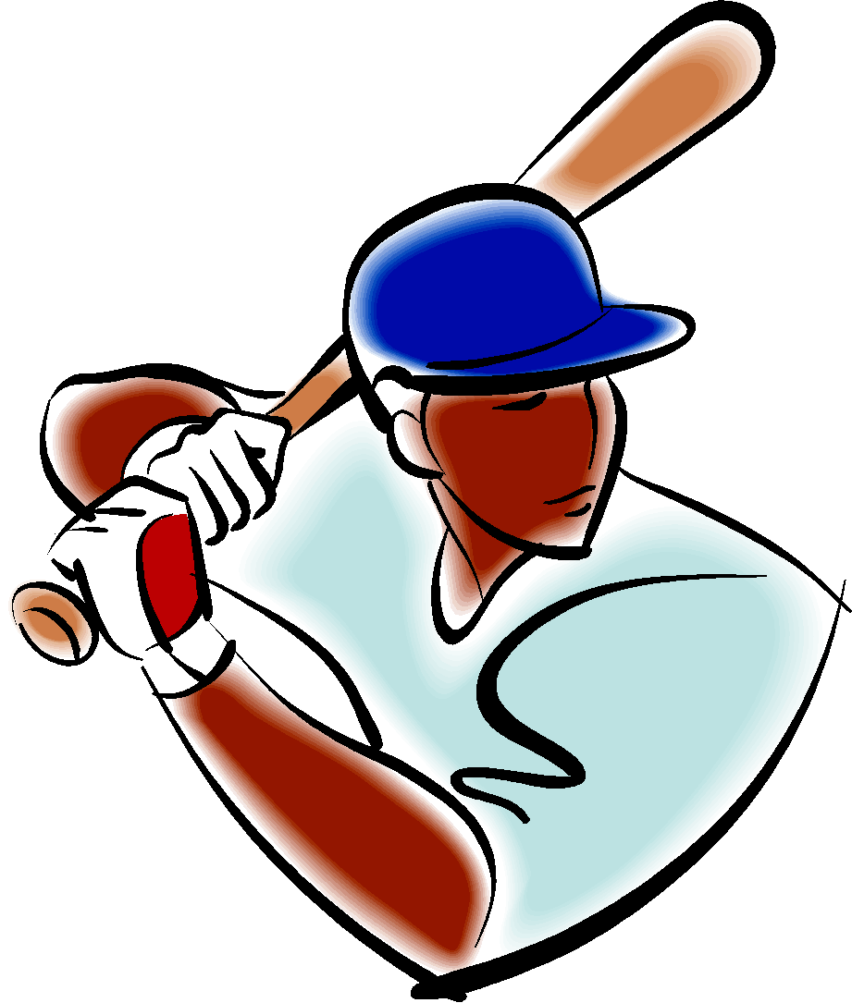
BE ALERT

CHECK PLAYING FIELDS
FOR HAZARDS

PLAYERS MUST WEAR
PROPER EQUIPMENT

ENSURE EQUIPMENT IS IN
GOOD SHAPE

MAINTAIN CONTROL OF THE
SITUATION

MAINTAIN DISCIPLINE

BE ORGANIZED

KNOW PLAYERS’ LIMITS AND
DON’T EXCEED THEM

MAKE IT FUN!
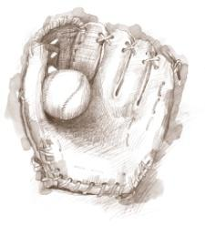

CONDITIONING & STRETCHING

Conditioning is an intricate part of accident prevention. Extensive studies on the effect of conditioning, commonly known as “warm-up,” have demonstrated that:

- The stretching and contracting of muscles just before an athletic activity improves general control of movements, coordination and alertness.
- Such drills also help develop the strength and stamina needed by the average youngster to compete with minimum accident exposure.

The purpose of stretching is to increase flexibility within the various muscle groups and prevent tearing from overexertion. Stretching should never be done forcefully, but rather in a gradual manner to encourage looseness and flexibility.

Hints on Stretching:

- Stretch necks, backs, arms, thighs, legs and calves.
- Don’t ask the child to stretch more that he or she is capable of.
- Hold the stretch for at least 10 seconds.
- Don’t allow bouncing while stretching. This tears down the muscle rather than stretching it.
- Have one of the players lead the stretching exercises.

Hints on Calisthenics:

- Repetitions of at least 10.
- Have kids synchronize their movements.
- Vary upper body with lower body.
- Keep the pace up for a good cardio-vascular workout.

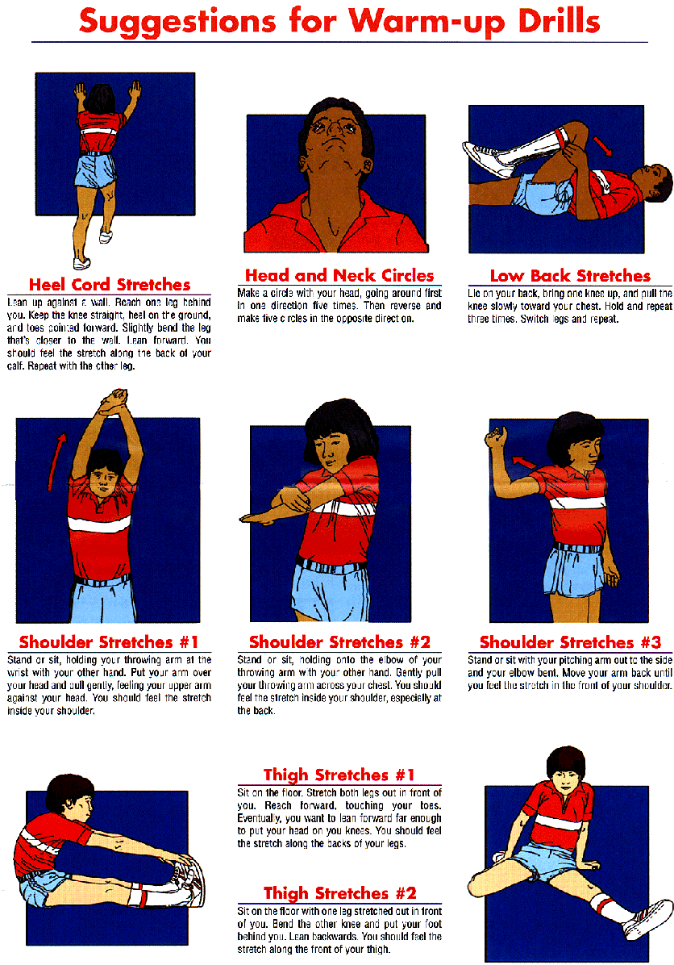

PITCHING

PITCH COUNT:

PITCH COUNT DOES MATTER!

Little League managers and coaches are usually quick to teach their
Pitchers how to get movement on the ball. Unfortunately, the technique that older players use is not appropriate for children thirteen (13) years and younger. The snapping of the arm used to develop this technique will most probably lead to serious injuries to the child as he/she matures.

Arm stress during the acceleration phase of throwing affects both the inside and the outside of the growing elbow. On the inside, the structures are subjected to distraction forces, causing them to pull apart. On the outside, the forces are compressive in nature with different and potentially more serious consequences.

The key structures on the inside (or medial) aspect of the elbow include the tendons of the muscles that allow the wrist to flex and the growth plate of the medial epicondyle (“Knobby” bone on the inside of the elbow). The forces generated during throwing can cause this growth plate to pull away (avulse) from the main bone. If the distance between the growth plate and main bone is great enough, surgery is the only option to fix it. This growth plate does not fully adhere to the main bone until age 15!

Similarly, on the outside (or lateral) aspect of the elbow, the two bony surfaces can be damaged by compressive forces during throwing. This scenario can lead to a condition called Avascular Necrosis or Bone Cell Death because of compromise of the local blood flow to that area. This disorder is permanent and often leads to fragments of the bone breaking away (loose bodies) which float in the joint and can cause early arthritis. This loss of elbow motion and function often precludes further participation.

Studies have demonstrated that curveballs cause most problems at the inside of the elbow due to the sudden contractive forces of the wrist musculature. Fastballs, on the other hand, place more force at the outside of the elbow. Sidearm delivery, in one study, led to elbow injuries in 74% of pitchers compared with 27% in pitchers with a vertical delivery style.

Dr. Glenn Fleisig at the American Sports Medicine Institute is in the process of finalizing the results of a study funded by USA Baseball that evaluated pitch counts in skeletally immature athletes as they relate to both elbow and shoulder injuries. The study included 500 athletes, ages 9-14, from the Birmingham, Alabama area. Each child who pitched in a game was called after the game and interviewed over the phone. The investigators were able to conduct over 3000 interviews. Approximately 200 of the 500 pitchers had videotape of their mechanics.

PRELIMINARY DATA HAVE DEMONSTRATED THE FOLLOWING:
- A significantly higher risk of elbow injury occurred after pitchers reached 50 pitches/outing.
- A significantly higher risk of shoulder injury occurred after pitchers reached 75 pitches/outing.\
- In one season, a total of 450 pitches or more led to cumulative injury to the elbow and the shoulder.
- The mechanics, whether good or bad, did not lead to an increased incidence of arm injuries.
- The preliminary data suggest that throwing curveballs increases risk of injury to the shoulder more so than the elbow; however, subset analysis is being undertaken to investigate whether or not the older children were the pitchers throwing the curve.
- The pitchers who limited their pitching repertoire to the fastball and change-up had the lowest rate of injury to their throwing arm.
- A slider increased the risk of both elbow and shoulder problems.
- Based on this research, HNLL recommends against the teaching or throwing of curveballs under the age of 13. If a curveball is taught, the Manager should instruct the child to throw the curveball like a football without snapping the arm or the wrist. If the manager or coach is unsure how to do this, he/she can contact a HNLL board member for further instruction.
- Ice is a universal First-Aid treatment for minor sports injuries. Ice controls the pain and swelling. Pitchers should be taught how to ice their arms at the end of a game. If the manager or coach is unsure how to do this, he/she can consult teaching materials or contact a HNLL board member for further instruction.

CHILDREN SHOULD NOT BE ENCOURAGED TO “PLAY THROUGH PAIN.”
PAIN IS A WARNING SIGN OF INJURY.
IGNORING IT CAN LEAD TO GREATER INJURY.

HYDRATION:

Good nutrition is important for children. Sometimes, the most important nutrient children need is water – especially when they’re physically active. When children are physically active, their muscles generate heat thereby increasing their body temperature. As their body temperature rises, their cooling mechanism - sweat – kicks in. When sweat evaporates, the body is cooled. Unfortunately, children get hotter than adults during physical activity and their body’s cooling mechanism is not as efficient as adults. If fluids are not replaced, children can become overheated.

We usually think about dehydration in the summer months when hot temperatures shorten the time it takes for children to become overheated. But keeping children well hydrated is just as important in the winter months. Additional clothing worn in the colder weather makes it difficult for sweat to evaporate, so the body does not cool as quickly.

It does not matter if it’s January or July; thirst is not an indicator of fluid needs. Therefore, children must be encouraged to drink fluids even when they do not feel thirsty.

Managers and coaches should schedule drink breaks every 15 to 30 minutes during practices on hot days and should encourage players to drink between every inning.

During any activity water is an excellent fluid to keep the body well hydrated. It’s economical too! Offering flavored fluids like sport drinks or fruit juice can help encourage children to drink. Sports drinks should contain between 6 and 8 percent carbohydrates (15 to 18 grams of carbohydrates per cup) or less. If the carbohydrate levels are higher, the sports drink should be diluted with water. Fruit juice should also be diluted (1 cup juice to 1 cup water). Beverages high in carbohydrates like undiluted fruit juice may cause stomach cramps, nausea and diarrhea when the child becomes active. Caffeinated beverages (tea, coffee,
Colas) should be avoided because they are diuretics and can dehydrate the body further. Avoid carbonated drinks, which can cause gastrointestinal distress and may decrease fluid volume.

COMMON SENSE:

Playing safe boils down to using common sense. For instance, if you witnessed a strange person walking around the HNLL complex who looked like he/she didn’t belong there you would report the incident to a Board Member. There will always be a Board Member on site (see the Board of Directors roster on the league website to identify our Board Members)). The HNLL Board Member, after hearing your concerns, would investigate the matter and have the person in question removed before anything could happen if, indeed, that person did not belong there.

Another example of common sense – You witness kids throwing rocks or batting rocks on the HNLL complex. They are having fun but are unknowingly endangering others. Don’t just walk on by figuring that someone else will deal with the situation. Stop and explain to the kids what they are doing wrong and ask them to stop.

Webster’s Dictionary definition of common sense is: Native good judgment; sound ordinary sense. In other words, to use common sense is to realize the obvious. Therefore, if you witness something that is not safe, do something about it! And encourage all volunteers and parents to do the same.

EQUIPMENT:

The Equipment Director is an elected HNLL Board Member and is responsible for purchasing and distributing equipment to the individual teams. This equipment is checked and tested when it is issued but it is the Manager’s responsibility to maintain it. Managers should inspect equipment before each game and each practice.

The HNLL Equipment Director will promptly replace damaged and ill-fitting equipment.

Furthermore, kids like to bring their own gear. This equipment can only be used if it meets the requirements as outlined in this Safety Manual and the Official Little League Rule Book.

At the end of the season, all equipment must be returned to the HNLL Equipment Director. First-Aid kits and Safety Manuals must be turned in with the equipment.

- Each team, always in the dugout, and shall have seven (7) protective helmets, which must meet NOCSAE specifications and standards. These helmets will be provided by HNLL at the beginning of the season. If players decide to use their own helmets, they must meet NOCSAE specifications and standards.
- Each helmet shall have an exterior warning label. NOTE: The warning label cannot be embossed in the helmet but must be placed on the exterior portion of the helmet and be visible and easy to read.
- Use of a helmet by the batter and all base runners is mandatory.
- Use of a helmet by a player/base coach is mandatory.
- Use of a helmet by an adult base coach is optional.
- All male players must wear athletic supporters.
- Male catchers must wear the metal, fiber or plastic type cup and a long-model chest protector.
- Female catchers must wear long or short model chest protectors.
- All catchers must wear chest protectors with neck collar, throat guard, shin guards and catcher’s helmet, all of which must meet Little League specifications and standards.
- All catchers must wear a mask, “dangling” type throat protector and catcher’s helmet during practice, pitcher warm-up, and games. NOTE: Skullcaps are not permitted.
- If the gripping tape on a bat becomes unraveled, the bat must not be used until it is repaired.
- Bats with dents, or that are fractured in any way, must be discarded.
- Only Official Little League balls will be used during practices and games.
- No wood bats at any time.
- Make sure that the equipment issued to you is appropriate for the age and size of the kids on your team. If it is not, get replacements from the Equipment Manager.
- Make sure helmets fit.
- Replace questionable equipment immediately by notifying the HNLL Equipment Manager.
- Make sure that players respect the equipment that is issued.
- Pitchers can no longer wear multi-colored gloves.

WEATHER

Most of our days in Southern California are warm and sunny but there are those days when the weather turns bad and creates unsafe weather conditions.

Rain:
If it begins to rain:
- Evaluate the strength of the rain. Is it a light drizzle or is it pouring?
- Determine the direction the storm is moving.
- Evaluate the playing field as it becomes more and more saturated.
- Stop practice if the playing conditions become unsafe -- use common sense. If playing a game, consult with the other manager and the umpire to formulate a decision.

Lightning:
The average lightning stroke is 5-6 miles long with up to 30 million volts at 100,000 amps flow in less than a tenth of a second.

The average thunderstorm is 6-10 miles wide and moves at a rate of 25 miles per hour.

Once the leading edge of a thunderstorm approaches to within 10 miles, you are at immediate risk due to the possibility of lightning strokes coming from the storm’s overhanging anvil cloud. This fact is the reason that many lightning deaths and injuries occur with clear skies overhead.

On average, the thunder from a lightning stroke can only be heard over a distance of 3-4 miles, depending on terrain, humidity and background noise around you. By the time you can hear the thunder, the storm has already approached to within 3-4 miles!
The sudden cold wind that many people use to gauge the approach of a thunderstorm is the result of downdrafts and usually extends less than 3 miles from the storm’s leading edge. By the time you feel the wind, the storm can be less than 3 miles away!

If you can HEAR, SEE OR FEEL a THUNDERSTORM:
- Suspend all games and practices immediately.
- Stay away from metal including fencing and bleachers.
- Do not hold metal bats.
- Get players to walk, not run to their parent’s or designated driver’s cars and wait for your decision on whether or not to continue the game or practice.

Hot Weather:
One thing we do get in Southern California is hot weather. Precautions must
be taken to make sure the players on your team do not dehydrate or
hyperventilate.

- Suggest players take drinks of water when coming on and going off the field between innings. (Drinking fountains are located in all dugouts)
- If a player looks distressed while standing in the hot sun, substitute that player and get him/her into the shade of the dugout A.S.A.P.
- If a player should collapse as a result of heat exhaustion, call 9-1-1 immediately. Get the player to drink water and use the instant ice bags supplied in your First-Aid Kit to cool him/her down until the emergency medical team arrives. (See section on Hydration)

Ultraviolet Ray Exposure:
This kind of exposure increases and athlete’s risk of developing a specific type of skin cancer known as melanoma.

The American Academy of Dermatology estimates that children receive 80% of their lifetime sun exposure by the time that they are 18 years old.

Therefore, HNLL will recommend the use of sunscreen with a SPF (sun protection factor) of at least 15 as a means of protection from damaging ultraviolet light.

EVACUATION PLAN

Severe storms, lightning, earthquakes and fire are all possible in Southern California. For this reason, HNLL must have an evacuation plan.

An emergency alarm system has been added to the Snack Bar and in the Score box. If an emergency should arise (i.e., Fire) that would require evacuation, the alarm will sound.

- At that time all players will return to the dugout and wait for their parents to come and get them.
- If a player’s parent is not attending the game, the Manager will take responsibility for evacuating that child.
- Once parents have obtained their children, they will proceed to their cars in a calm and orderly manner.
- Drivers will then proceed slowly and cautiously out of the facility, observing the 5 MPH speed limit.
- Once outside the facility, drivers will observe the posted speed limits.

STORAGE SHED PROCEDURES

The following applies to all the storage sheds used by Hesperia National Little League and further applies to anyone who has been issued keys by Hesperia National Little League to use these sheds.

- Keys to the equipment sheds will only be issued by HNLL’s Facilities Director or League President.
- A record shall be kept of all individuals possessing keys.
- Keys will be returned to the Facilities Director or League President immediately once someone ceases to have responsibilities for equipment sheds.
- All storage sheds will be kept locked at all times.
- All individuals with keys to the equipment sheds are aware of their responsibility for the orderly and safe storage of heavy machinery, hazardous materials, fertilizers, poisons, tools, etc...
- Before the use of any machinery located in the shed (i.e., lawn mowers, weed whackers, lights, scoreboards, public address systems, etc.) please locate and read the written operating procedures for that equipment.
- All chemicals or organic materials stored in storage sheds shall be properly marked and labeled and stored in its original container if available.
- Any witnessed “loose” chemicals or organic materials within these sheds should be cleaned up and disposed of immediately to prevent accidental poisoning.
- Keep products in their original container with the labels in place.
- Use poison symbols to identify dangerous substances.
- Dispose of outdated products as recommended.
- Use chemicals only in well-ventilated areas.
- Wear proper protective clothing, such as gloves or a mask when handling toxic substances.

GENERAL FACILITY

- All bleachers will have safety rails.
- All bleachers will have protective awnings to stop fly balls.
- All dugouts will have bat racks.
- The backstops will always be padded and painted green for the safety of the catcher.
- The dugouts will be always clean and free of debris.
- Dugouts and bleachers will be free of protruding nails and wood slivers.
- Home plate, batter’s box, bases and the area around the pitcher’s mound will be checked periodically for tripping and stumbling hazards.
- Materials used to mark the field will consist of a non-irritating white pigment (no lime).
- Chain-link fences will be checked regularly for holes, sharp edges, and loose edges and will be repaired or replaced accordingly.
- The yellow safety caps on chain-link fences will be checked regularly for cracks and will be repaired or replaced accordingly.

Manager & Coaches Clinic

There will be a Manager & Coaches Clinic on Saturday, February 11, 2023, at Coleman Field from 3pm to 5pm. This clinic will go over basic information for both beginning and advanced coaches. We will go over all the information you need for the 2023 season.

All managers and coaches will be required to attend. Should you have any questions, please contact your Division Director.

CPR & First Aid Class
It is mandatory that all managers and coaches be CPR & First Aid certified for the 2023 season. All managers & coaches will be required to show a CPR & First Aid Certification Card or certificate when turning in their Volunteer Application.

.

ACCIDENT REPORTING PROCEDURE

WHAT TO REPORT-

An incident that causes any player, manager, coach, umpire, or volunteer to receive medical treatment and/or first aid must be reported to the HNLL Safety Officer. This includes even passive treatments such as the evaluation and diagnosis of the extent of the injury.

WHEN TO REPORT-

All such incidents described above must be reported to the HNLL Safety
Officer within 24 hours of the incident, the sooner the better. The HNLL Safety Officer is Bernice Pond. She can be reached at the following:
Email: bernicepondtc@gmail.com
The HNLL Safety Officer Contact information will be always posted at the snack bars.

HOW TO MAKE A REPORT-

Reporting incidents can come in a variety of forms. Most typically, they are telephone conversations. At a minimum, the following information must be provided:

- The name and phone number of the individual involved.
- The date, time, and location of the incident.
- As detailed a description of the incident as possible.
- The preliminary estimation of the extent of any injuries.
- The name and phone number of the person reporting the incident.

TEAM MANAGERS RESPONSIBILITY -
The manager will fill out the HNLL Accident Investigation Form and submit it to the HNLL Safety Officer within 24 hours of the incident. (HNLL Accident Investigation Forms can be found in the Appendix)

Accidents occurring outside the team (i.e., spectator injuries, concession stand injuries and third-party injuries) shall be handled directly by the HNLL Safety Officer.

HNLL SAFETY OFFICER’S RESPONSIBILITIES -
Within 24 hours of receiving the HNLL Accident Investigation Form, the
HNLL Safety Officer will contact the injured party or the party’s parents
and.
- verify the information received.
- obtain any other information deemed necessary.
- check on the status of the injured party; and
- if the injured party required other medical treatment (i.e., Emergency Room visit, doctor’s visit, et.) will advise the parent or guardian of the Hesperia National Little League’s insurance coverage and the provision for submitting any claims.

If the extent of the injuries is more than minor in nature, the HNLL Safety Officer shall periodically call the injured party to:
- Check on the status of any injuries, and
- Check if any other assistance is necessary in areas such as submission of insurance forms, etc., until such time as the incident is considered “closed” (i.e., no further claims are expected and/or the individual is participating in the League again).

INSURANCE POLICIES

Little League accident insurance covers only those activities approved or sanctioned by Little League Baseball, Incorporated. Hesperia National Little League (Majors), Minor League, Junior League, Senior League, Farm League and Tee Ball participants shall not participate as a Little League (Majors), Minor League, Junior League, Senior League, Farm League and Tee Ball team in games with other teams of other programs or in tournaments except those authorized by Little League Baseball, Incorporated.

Hesperia National Little League (Majors), Minor League, Junior League, Senior League, Farm League and Tee Ball participants may participate in other programs during the Little League (Majors), Minor League, Junior League, Senior League, Farm League and Tee Ball regular season and tournament provided such participation does not disrupt the Little League (Majors), Minor League, Junior League, Senior League, Farm League and Tee Ball season or tournament team.

Unless expressly authorized by the Board of Directors of HNLL, games played for any purpose other than to establish a League champion or as part of the International Tournament are prohibited. (See IX - Special Games, pg.15 in the Rule Book for further clarification)

EXPLANATION OF COVERAGE:

The AIG/LLB Little League’s insurance policy (see in Appendix) is designed to afford protection to all participants at the most economical cost to HNLL. It can be used to supplement other insurance carried under a family policy or insurance provided by a parent’s employer. If there is no other coverage, AIG/LLB Little League insurance - which is purchased by the HNLL, not the parent - takes over and provides benefits, after a $50 deductible per claim, for all covered injury treatment costs up to the maximum stated benefits.

This plan makes it possible to offer exceptional, low-cost protection with assurance to parents that adequate coverage is always in force during the season.

HOW THE INSURANCE WORKS

- First have the child’s parents file a claim under their insurance policy, Blue Cross, Blue Shield or any other insurance protection available.
- Should the family’s insurance plan not fully cover the injury treatment, the Little League AIG/LLB Policy will help pay the difference, after a $50 deductible per claim, up to the maximum stated benefits.
- If the child is not covered by any family insurance, the Little League CAN Policy becomes primary and will provide benefits for all covered injury treatment costs, after a $50 deductible per claim, up to the maximum benefits of the policy.
- Treatment of dental injuries can extend beyond the normal fifty-two-week period if dental work must be delayed due to physiological changes of a growing child. Benefits will be paid at the time treatment is given, even though it may be some years later. Maximum dollar benefit is $500 for eligible dental treatment after the normal fifty-two-week period, subject to the $50 deductible per claim.

Filing a Claim:

When filing a claim, (see claim forms in appendix) all medical costs should be fully itemized. If no other insurance is in effect, a letter from the parent’s/guardians or claimant’s employer explaining the lack of Group or Employer insurance must accompany a claim form.

On dental claims, it will be necessary to fill out a Major Medical Form, as well as a Dental Form; then submit them to the insurance company of the claimant, or parent(s)/guardian(s), if claimant is a minor. “Accident damage to whole, sound, normal teeth as a direct result of an accident” must be stated on the form and bills. Forward a copy of the insurance company’s response to Little League
Headquarters. Include the claimant’s name, League ID, and year of the injury on the form.

Claims must be filed with the HNLL Safety Officer. He/she forwards them to Little League Baseball, Incorporated, PO Box 3485, Williamsport, PA, 17701. Claim officers can be contacted at (717) 327-1674 and fax (717) 326-1074. Contact the HNLL Safety Officer for more information.

CONCESSION STAND SAFETY

- No person under league age 16 will be allowed behind the counter in the concession stands.
- People working in the concession stands will be trained in safe food preparation. Training will cover safe use of the equipment. This training will be provided by a HNLL Board Member.
- Cooking equipment will be inspected periodically and repaired or replaced if need be.
- Propane tanks will be turned off at the grill and at the tank after use.
- Food not purchased by HNLL to sell in its concession stands will not be cooked, prepared, or sold in the concession stands.
- Cooking grease will be stored safely in containers away from open flames.
- Carbon Dioxide tanks will be secured with chains so they stand upright and can’t fall over. Report damaged tanks or valves to the supplier and discontinue use.
- Cleaning chemicals must be stored in a locked container.
- A Certified Fire Extinguisher suitable for grease fires must be always placed in plain sight.
- All concession stand workers are to be instructed on the use of fire extinguishers.
- A fully stocked First Aid Kit will be placed in each Concession Stand.
- The Concession Stand main entrance door will not be locked or blocked while people are inside.

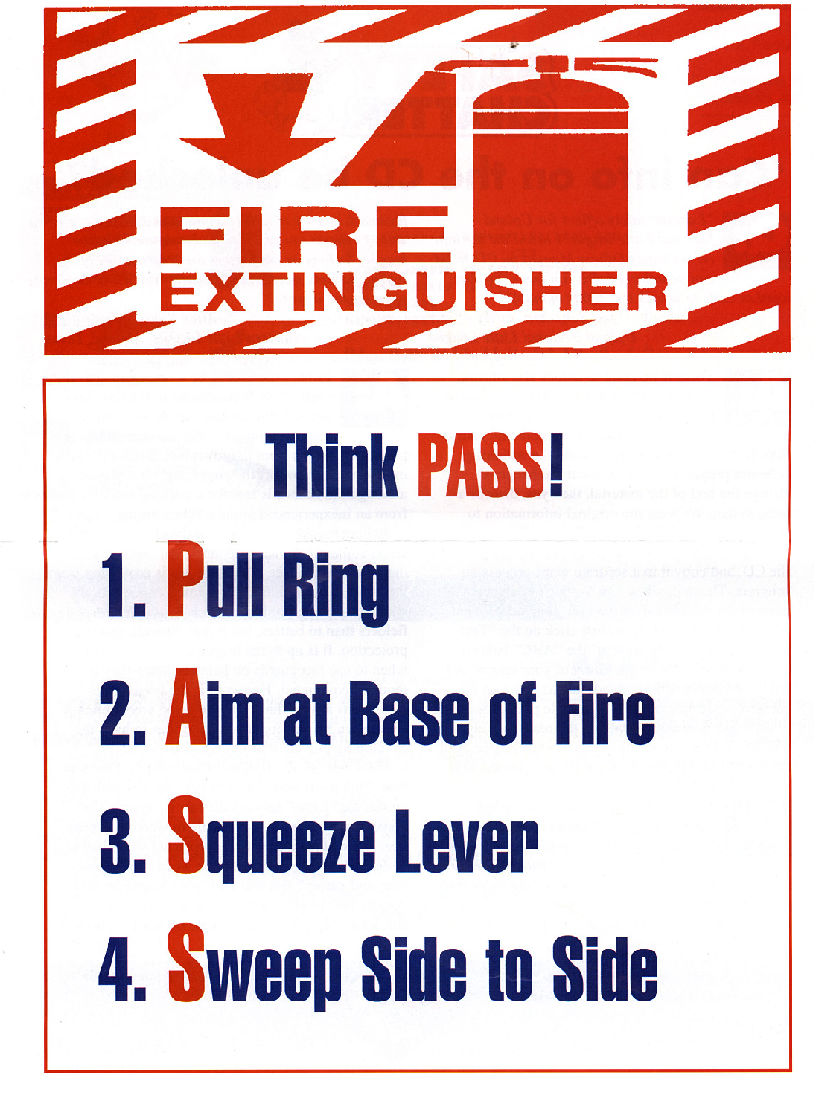

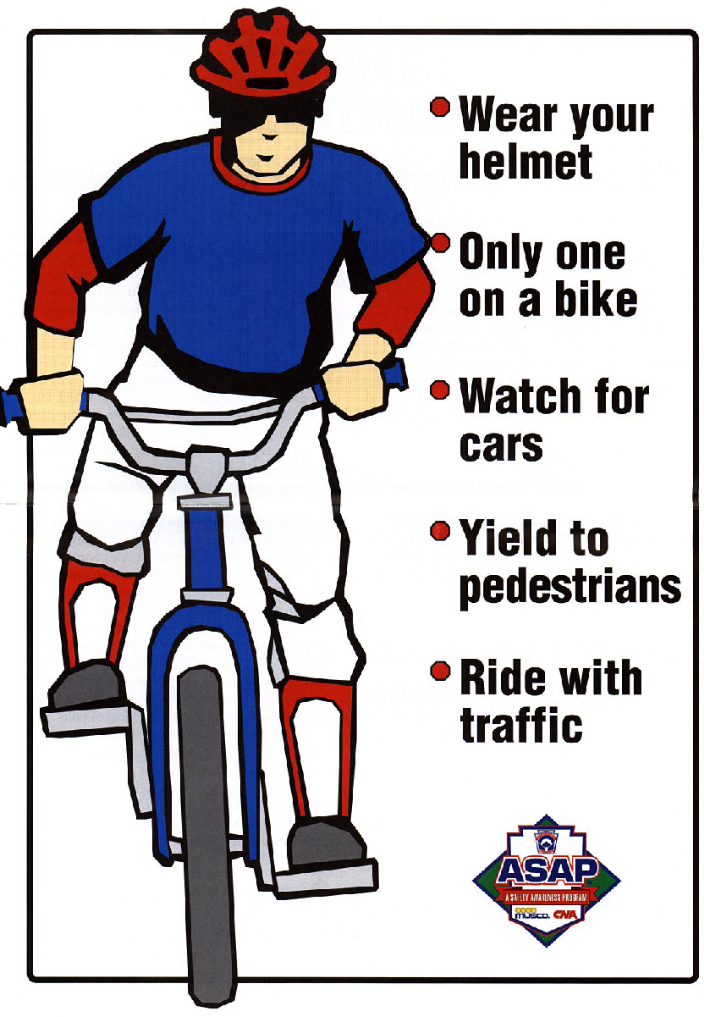

CHILD ABUSE

VOLUNTEERS:
Volunteers are the greatest resource Little League has in aiding children’s development into leaders of tomorrow. But some potential volunteers may be attracted to Little League to be near children for abusive reasons.

Big Brothers/Big Sisters of America defines child sexual abuse as “the exploitation of a child by an older child, teen or adult for the personal gratification of the abusive individual.” So, abusing a child can take many forms, from touching to non-touching offenses.

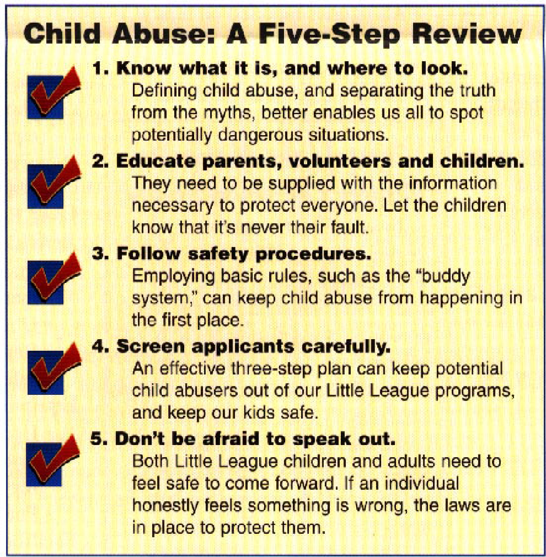
Child victims are usually made to feel as if they have brought the abuse upon themselves; they are made to feel guilty. For this reason, sexual abuse victims seldom disclose the victimization. Consider this: Big Brothers/Big Sisters of America contend that for every child abuse case reported, ten more go unreported. Children need to understand that it is never their fault, and both children and adults need to know what they can do to keep it from happening.

Anyone can be an abuser and it could happen anywhere. By educating parents, volunteers and children, you can help reduce the risk it will happen at Hesperia National Little League.

Like all safety issues, prevention is the key. Hesperia National Little League has a three-step plan for selecting caring, competent and safe volunteers.

APPLICATION: To include residence information, employment history and three personal references from non-relatives. All potential volunteers must fill out the application that clearly asks for information about prior criminal convictions. The form also points out that all positions are conditional based on the information received back from a background check.

INTERVIEW: Make all applicants aware of the policy that no known child-sex offender will be given access to children in the Little League Program.

REFERENCE CHECKS: Make sure the information given by the applicant is corroborated by references.

REPORTING:
In the unfortunate case that child sexual abuse is suspected, you should
immediately contact the HNLL President, or a HNLL Board Member if the
President is not available, to report the abuse. HNLL along with district
administrators will contact the proper law enforcement agencies.

INVESTIGATION:
HNLL will appoint an individual with significant professional background to receive and act on abuse allegations. These individuals will act in a confidential manner and serve as the League’s liaison with the local law enforcement community. Little League volunteers should not attempt to investigate suspected abuse on their own.

SUSPENDING/TERMINATION:
When an allegation of abuse is made against a Little League volunteer, it is our duty to protect the children from any possible further abuse by keeping the alleged abuser away from children in the program. If the allegations are substantiated, the next step is clear -- assuring that the individual will not have any further contact with the children in the League.

IMMUNITY FROM LIABILITY:
According to Boys & Girls Clubs of America, “Concern is often expressed over the potential for criminal or civil liability if a report of abuse is subsequently found to be unsubstantiated.” However, we want adults and Little Leaguers to understand that they shouldn’t be afraid to come forward in these cases, even if it isn’t required and even if there is a possibility of being wrong. All states provide immunity from liability to those who report suspected child abuse in “good faith.” At the same time, there are also rules in place to protect adults who prove to have been inappropriately accused.

MAKE OUR POSITION CLEAR:
Make adults and kids aware that Little League Baseball and HNLL will not tolerate child abuse, in any form.

THE BUDDY SYSTEM:
It is an old maxim, but it is true: There is safety in numbers. Encourage kids to move about in a group of two or more children of similar age, whether an adult is present or not. This includes travel, leaving the field, or using the restroom areas. It is far more difficult to victimize a child if they are not alone.
ACCESS:
Controlling access to areas where children are present -- such as the dugout or restrooms -- protects them from harm by outsiders. It’s not easy to control the access of large outdoor facilities, but visitors could be directed to a central point within the facility. Individuals should not be allowed to wander through the area without the knowledge of the Managers, Coaches, Board Directors or any other Volunteer.

LIGHTING:
Child sexual abuse is more likely to happen in the dark. The lighting of fields, parking lots and all indoor facilities where Little League functions are held should be bright enough so that participants can identify individuals as they approach, and observers can recognize abnormal situations.

BATHROOM FACILITIES:
Little Leaguers are capable of using toilet facilities on their own, so there should be no need for an adult to accompany a child into rest room areas. There can sometimes be special circumstances under which a child requires assistance to toilet facilities, for instance when the T-Ball and Challenge divisions, but there should still be adequate privacy for that child. Again, we can utilize the “buddy system” here. ALL MANAGERS ARE ENCOURAGED TO ENFORCE THIS BUDDY SYSTEM.

FICTION & FACT ABOUT SEX OFFENDERS:

“Sex abusers are dirty old men.”
Not true. While sex abusers cut across socioeconomic levels, educational levels and race, the average age of a sex offender has been established at 32.

“Strangers are responsible for most of the sexual abuse.”
Fact: 80-85% of all sexual abuse cases in the US are perpetrated by an individual familiar to the victim. Less than 20% of all abusers are strangers.

“Most sex abusers suffer from some form of serious mental illness or psychosis.”
Not true. The actual figure is more like 10%, almost the same as the figure found in the general population of the United States.

“Most sex abusers are homosexuals.”
Also, not true. Most are heterosexual.

“Children usually lie about sexual abuse, anyway.”
In fact, children rarely lie about being sexually abused. If they say it, don’t ignore it.

“It only happens to girls.”
While females do comprise the largest number of sexual abuse victims, it is now believed that the number for male victims is much higher than reported.

TRANSPORTATION

Before any manager or designated coach can transport any HNLL child,
other than his/her own, anywhere, he or she must:

- Have a valid California Driver’s License.
- Wear corrective lenses when operating a vehicle if the Driver’s License stipulates that the operator must wear corrective lenses.
- Have correct class of license for the vehicle he or she is driving.
- Not carry more children in their vehicle than they have seat belts for.
- Make sure that the vehicle is in good running order and that it would pass a CHP vehicle safety inspection if spontaneously given.
- Not drive in a careless or reckless manner.
- Not drive under the influence of alcohol, drugs, or medication.
- Always obey all traffic laws and speed limits.
- Never transport a child without returning him/her to the point of origin.

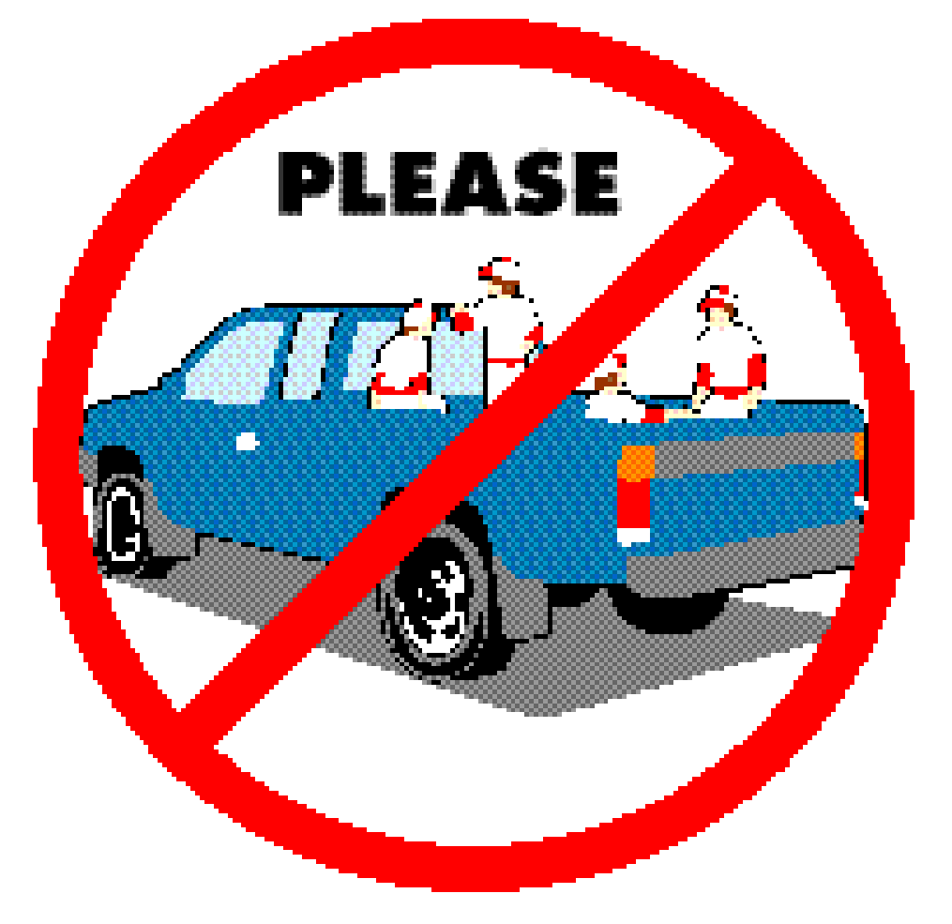

HEALTH AND MEDICAL - Giving First Aid

WHAT IS FIRST AID?
First-Aid means exactly what the term implies -- it is the first care given to a victim. It is usually performed by the first person on the scene and continued until professional medical help arrives, (9-1-1 paramedics). At no time should anyone administering First-Aid go beyond his or her capabilities. Know your limits!

The average response time on 9-1-1 calls is 5-7 minutes in route paramedics are always in constant communication with the local hospital preparing them for whatever emergency action might need to be taken. You cannot do this. Therefore, do not attempt to transport a victim to a hospital. Perform whatever First Aid you can and wait for the paramedics to arrive.

FIRST AID-KITS:
First Aid Kits will be furnished to each team at the beginning of the season.

Keep at least two quarters inside the First-Aid Kit for emergency telephone calls.

The First Aid Kit will become part of the Team’s equipment package and shall be taken to all practices, batting cage practices, games (whether season or post-season) and any other HNLL Little League event where children’s safety is at risk.

To replenish materials in the Team First Aid Kit, the Manager or designated
Coaches must contact the HNLL Safety Officer. (See contact information and address in phone # section of this Safety Manual.) THIS CONTACT SHOULD BE MADE IMMEDIATELY!

First Aid Kits must be turned in at the end of the season along with your equipment package.

GOOD SAMARITAN LAWS:
There are laws to protect you when you help someone in an emergency. The “Good Samaritan Laws” give legal protection to people who provide emergency care to ill or injured persons. When citizens respond to an emergency and act as a reasonable and prudent person would under the same conditions, Good Samaritan immunity generally prevails. This legal immunity protects you, as a rescuer, from being sued and found financially responsible for the victim’s injury. For example, a reasonable and prudent person would –
- Move a victim only if the victim’s life was endangered.
- Ask a conscious victim for permission before giving care.
- Check the victim for life-threatening emergencies before providing further care.
- Summon professional help to the scene by calling 9-1-1.
- Continue to provide care until more highly trained personnel arrive.

Good Samaritan laws were developed to encourage people to help others in emergency situations. They require that the “Good Samaritan” use common sense and a reasonable level of skill, not to exceed the scope of the individual’s training in emergency situations. They assume each person would do his or her best to save a life or prevent further injury.

People are rarely sued for helping in an emergency. However, the existence of Good Samaritan laws does not mean that someone cannot sue. In rare cases, courts have ruled that these laws do not apply in cases when an individual rescuer’s response was grossly or willfully negligent or reckless or when the rescuer abandoned the victim after initiating care.

PERMISSION TO GIVE CARE:

If the victim is conscious, you must have his/her permission before giving first aid. To get permission you must tell the victim who you are, how much training you have, and how you plan to help. Only then can a conscious victim give you permission to give care.

Do not give care to a conscious victim who refuses your offer to give care. If the conscious victim is an infant or child, permission to give care should be obtained from a supervising adult when one is available. If the condition is serious, permission is implied if a supervising adult is not present.

Permission is also implied if a victim is unconscious or unable to respond. This means that you can assume that, if the person could respond, he or she would agree to care.

TREATMENT AT SITE:

SOME IMPORTANT DO’S AND DON'TS

Do . . .
- Access the injury. If the victim is conscious, find out what happened, where it hurts, watch for shock.
- Know your limitations.
- Call 9-1-1 immediately if person is unconscious or seriously injured.
- Look for signs of injury (blood, black-and-blue, deformity of joint etc.)
- Listen to the injured player describe what happened and what hurts if conscious. Before questioning, you may have to calm and soothe an excited child.
- Feel gently and carefully the injured area for signs of swelling or grating of broken bone.
- Talk to your team afterwards about the situation if it involves them. Often players are upset and worried when another player is injured. They need to feel safe and understand why the injury occurred.

Don’t . . .
- Administer any medications.
- Provide any food or beverages (other than water).
- Hesitate in giving aid when needed.
- Be afraid to ask for help if you’re not sure of the proper Procedure, (i.e., CPR, etc.)
- Transport injured individual except in extreme emergencies.

9-1-1 EMERGENCY NUMBER:

The most important help that you can provide to a victim who is seriously injured is to call for professional medical help. Make the call quickly, preferably from a cell phone near the injured person. If this is not possible, send someone else to make the call from a nearby telephone. Be sure that you or another caller follows these four steps.

- First Dial 9-1-1.
- Give the dispatcher the necessary information. Answer any questions that he or she might ask. Most dispatchers will ask:
- The exact location or address of the emergency. Include the name of the city or town, nearby intersections, landmarks, etc.
- The telephone number from which the call is being made.
- The caller’s name.
- What happened - for example, a baseball related injury, bicycle accident, fire, fall, etc.
- How many people are involved?
- The condition of the injured person - for example, unconsciousness, chest pains, or severe bleeding.
- What help (first aid) is being given.
- Do not hang up until the dispatcher hangs up. The EMS dispatcher may be able to tell you how to best care for the victim.
- Continue to care for the victim till professional help arrives.
- Appoint somebody to go to the street and look for the ambulance and fire engine and flag them down if necessary. This saves valuable time. Remember, every minute counts.
WHEN TO CALL:

If the injured person is unconscious, call 9-1-1 immediately. Sometimes a conscious victim will tell you not to call an ambulance, and you may not be sure what to do. Call 9-1-1 anyway and request paramedics if the victim -

- Is or becomes unconscious.
- Has trouble breathing or is breathing in a strange way.
- Has chest pain or pressure.
- Is bleeding severely.
- Has pressure or pain in the abdomen that does not go away.
- Is vomiting or passing blood.
- Has seizures, a severe headache, or slurred speech.
- Appears to have been poisoned.
- Has injuries to the head, neck or back.
- Has possible broken bones.
- If you have any doubt at all, call 9-1-1- and requests paramedics.

Also call 9-1-1 for any of these situations:

- Fire or explosion
- Downed electrical wires
- Swiftly moving or rapidly rising water
- Presence of poisonous gas
- Vehicle Collisions
- Vehicle/Bicycle Collisions
- Victims who cannot be moved easily

CHECKING THE VICTIM:

Checking the Injured:
The Hesperia National Little League Board of Directors requests that only trained volunteers are on the field to check and administer first aid/CPR to the child. The safety and welfare of the child is the first priority for the league; therefore, we ask that all non-trained individuals stay off the field.

Conscious Victims:
If the victim is conscious, ask what happened. Look for other life-threatening conditions and conditions that need care or might become life threatening. The victim may be able to tell you what happened and how he or she feels. This information helps determine what care may be needed. This check has two steps:

- Talk to the victim and to any people standing by who saw the accident take place.
- Check the victim from head to toe, so you do not overlook any problems.
- Do not ask the victim to move, and do not move the victim yourself.
- Examine the scalp, face, ears, nose, and mouth.
- Look for cuts, bruises, bumps, or depressions.
- Watch for changes in consciousness.
- Notice if the victim is drowsy, not alert, or confused.
- Look for changes in the victim’s breathing. A healthy person breathes regularly, quietly, and easily. Breathing that is not normal includes noisy breathing such as gasping for air; making rasping, gurgling, or whistling sounds; breathing unusually fast or slow; and breathing that is painful.
- Notice how the skin looks and feels. Note if the skin is reddish, bluish, pale or gray.
- Feel with the back of your hand on the forehead to see if the skin feels unusually damp, dry, cool, or hot.
- Ask the victim again about the areas that hurt.
- Ask the victim to move each part of the body that doesn’t hurt.
- Check the shoulders by asking the victim to shrug them.
- Check the chest and abdomen by asking the victim to take a deep breath.
- Ask the victim if he or she can move the fingers, hands, and arms.
- Check the hips and legs in the same way.
- Watch the victim’s face for signs of pain and listen for sounds of pain such as gasps, moans or cries.
- Look for odd bumps or depressions.
- Think of how the body usually looks. If you are not sure if something is out of shape, check it against the other side of the body.
- Look for a medical alert tag on the victim’s wrist or neck. A tag will give you medical information about the victim, care to give for that problem, and who to call for help.
- When you have finished checking, if the victim can move his or her body without any pain and there are no other signs of injury, have the victim rest sitting up.
- When the victim feels ready, help him or her stand up.

Unconscious Victims:
If the victim does not respond to you in any way, assume the victim is unconscious. Call 9-1-1 and report the emergency immediately.

Checking an Unconscious Victim:

- Tap and shout to see if the person responds. If no response –
- Look, listen and feel for breathing for about 5 seconds.
- If there is no response, position victim on back, while supporting head and neck.
- Tilt head back, lift chin and pinch nose shut. (See breathing section to follow)
- Look, listen, and feel for breathing for about 5 seconds.
- If the victim is not breathing, give 2 slow breaths into the victim’s mouth.
- Check pulse for 5 to 10 seconds.
- Check for severe bleeding.

MUSCLE, BONE, OR JOINT INJURIES:

SYMPTOMS OF SERIOUS MUSCLE, BONE, OR JOINT INJURIES:
Always suspect a serious injury when the following signals are present:
- Significant deformity
- Bruising and swelling
- Inability to use the affected part normally
- Bone fragments sticking out of a wound
- Victim feels bones grating; victim felt or heard a snap or pop at the time of injury
- The injured area is cold and numb
- Cause of the injury suggests that the injury may be severe.

If any of these conditions exists, call 9-1-1 immediately and administer care to
a victim until the paramedics arrives.

TREATMENT FOR MUSCLE OR JOINT INJURIES:
- If ankle or knee is affected, do not allow victim to walk. Loosen or remove shoe; elevate leg.
- Protect skin with thin towel or cloth. Then apply cold, wet compresses or cold packs to affected area. Never pack a joint in ice or immerse in icy water.
- If a twisted ankle, do not remove the shoe -- this will limit swelling.
- Consult professional medical assistance for further treatment if necessary.

TREATMENT FOR FRACTURES:
Fractures need to be splinted in the position found and no pressure is to be put on the area. Splints can be made from almost anything; rolled up magazines, twigs, bats, etc...

TREATMENT FOR BROKEN BONES:
Once you have established that the victim has a broken bone, and you have called 9-1-1, all you can do is comfort the victim, keep him/her warm and still and treat for shock if necessary (see “Caring for Shock” section)

OSGOOD SCHLATTER'S DISEASE:
Osgood Schlatter's Disease is the “growing pains” disease. It is very painful for kids that have it. In a nutshell, the bones grow faster than the muscles and ligaments. A child must outgrow this disease. All you can do is make it easier for him or her by:
- Icing the painful areas.
- Making sure the child rests when needed.
- Using Ace or knee supports.

CONCUSSION:
Concussions are defined as any blow to the head. They can be fatal if the proper precautions are not taken.
- If a player, remove player from the game.
- See that victim gets adequate rest.
- Note any symptoms and see if they change within a short period of time.
- If the victim is a child, tell parents about the injury and have them monitor the child after the game.
- Urge parents to take the child to a doctor for further examination.
- If the victim is unconscious after the blow to the head, diagnose head and neck injury. DO NOT MOVE the victim. Call 9-1-1 immediately. (See below on how to treat head and neck injuries)

HEAD AND SPINE INJURIES:

WHEN TO SUSPECT HEAD AND SPINE INJURIES:
- A fall from a height greater than the victim’s height.
- Any bicycle, skateboarding, rollerblade mishap.
- A person found unconscious for unknown reasons.
- Any injury involving severe blunt force to the head or trunk, such as from a bat or line drive baseball.
- Any injury that penetrates the head or trunk, such as an impalement.
- A motor vehicle crash involving a driver or passengers not wearing safety belts.
- Any person thrown from a motor vehicle.
- Any person struck by a motor vehicle.
- Any injury in which a victim’s helmet is broken, including a motorcycle, batting helmet, industrial helmet.
- Any incident involving a lightning strike.

SIGNALS OF HEAD AND SPINE INJURIES:
- Changes in consciousness
- Severe pain or pressure in the head, neck, or back
- Tingling or loss of sensation in the hands, fingers, feet, and toes
- Partial or complete loss of movement of any body part
- Unusual bumps or depressions on the head or over the spine
- Blood or other fluids in the ears or nose
- Heavy external bleeding of the head, neck, or back
- Seizures
- Impaired breathing or vision as a result of injury
- Nausea or vomiting
- Persistent headache
- Loss of balance
- Bruising of the head, especially around the eyes and behind the ears

GENERAL CARE FOR HEAD AND SPINE INJURIES:
  - Call 9-1-1 immediately.
  - Minimize movement of the head and spine.
  - Maintain an open airway.
  - Check consciousness and breathing.
  - Control any external bleeding.
  - Keep the victim from getting chilled or overheated till paramedics arrive and take over care.

CONTUSION TO STERNUM:
Contusions to the Sternum are usually the result of a line drive that hits a player in the chest. These injuries can be very dangerous because if the blow is hard enough, the heart can become bruised and start filling up with fluid. Eventually the heart is compressed, and the victim dies. Do not downplay the seriousness of this injury.

- If a player is hit in the chest and appears to be all right, urge the parents to take their child to the hospital for further examination.
- If a player complains of pain in his chest after being struck, immediately call 9-1-1 and treat the player until professional medical help arrives.

SUDDEN ILLNESS:
When a victim becomes suddenly ill, he or she often looks and feels sick.

SYMPTOMS OF SUDDEN ILLNESS INCLUDE:
- Feeling light-headed, dizzy, confused, or weak
- Changes in skin color (pale or flushed skin), sweating
- Nausea or vomiting
- Diarrhea
- Changes in consciousness
- Seizures
- Paralysis or inability to move
- Slurred speech
- Impaired vision
- Severe headache
- Breathing difficulty
- Persistent pressure or pain.

CARE FOR SUDDEN ILLNESS:
  - Call 9-1-1
  - Help the victim rest comfortably.
  - Keep the victim from getting chilled or overheated.
  - Reassure the victim.
  - Watch for changes in consciousness and breathing.
  - Do not give anything to eat or drink unless the victim is fully conscious.

If the victim:
- Vomits -- Place the victim on his or her side.
- Faints -- Position him or her on the back and elevate the legs 8 to 10 inches if you do not suspect a head or back injury.
- Has a diabetic emergency -- Give the victim some form of sugar.
- Has a seizure -- Do not hold or restrain the person or place anything between the victim’s teeth. Remove any nearby objects that might cause injury. Cushion the victim’s head using folded clothing or a small pillow.

CARING FOR SHOCK:
Shock is likely to develop in any serious injury or illness. Signals of shock include:
- Restlessness or irritability
- Altered consciousness
- Pale, cool, moist skin
- Rapid breathing
- Rapid pulse.

Caring for shock involves the following simple steps:
  - Have the victim lie down. Helping the victim rest comfortably is important because pain can intensify the body’s stress and accelerate the progression of shock.
  - Control any external bleeding.
  - Help the victim maintain normal body temperature. If the victim is cool, try to cover him or her to avoid chilling.
  - Try to reassure the victim.
  - Elevate the legs about 12 inches unless you suspect head, neck, or back injuries or possible broken bones involving the hips or legs. If you are unsure of the victim’s condition, leave him or her lying flat.
  - Do not give the victim anything to eat or drink, even though he or she is likely to be thirsty.
  - Call 9-1-1 immediately. Shock can’t be managed effectively by first aid alone. A victim of shock requires advanced medical care as soon as possible.

BREATHING PROBLEMS/EMERGENCY BREATHING:

IF VICTIM IS NOT BREATHING:
- Position victim on back while supporting head and neck.
- With victim’s head tilted back and chin lifted, pinch the nose shut.
- Give two (2) slow breaths into victim’s mouth. Breathe in until chest gently rises.
- Check for a pulse at the carotid artery (use fingers instead of thumb).
- If pulse is present but person is still not breathing give 1 slow breath about every 5 seconds. Do this for about 1 minute (12 breaths).
- Continue rescue breathing as long as a pulse is present, but person is not breathing.

Once a victim requires emergency breathing you become the life support for that person -- without you the victim would be clinically dead. You must continue to administer emergency breathing and/or CPR until the paramedics get there. It is your obligation, and you are protected under the “Good Samaritan” laws.

IF VICTIM IS NOT BREATHING AND AIR WON’T GO IN:
- Re-tilt person’s head.
- Give breaths again.
- If air still won’t go in, place the heel of one hand against the middle of the victim’s abdomen just above the navel.
- Give up to 5 abdominal thrusts.
- Lift jaw and tongue and sweep out mouth with your fingers to free any obstructions.
- Tilt head back, lift chin, and give breaths again.
- Repeat breaths, thrust, and sweeps until breaths go in.
HEART ATTACK:

SIGNALS OF A HEART ATTACK:
Heart attack pain is most often felt in the center of the chest, behind the breastbone. It may spread to the shoulder, arm or jaw. Signals of a heart attack include:
- Persistent chest pain or discomfort - Victim has persistent pain or pressure in the chest that is not relieved by resting, changing position, or oral medication. Pain may range from discomfort to an unbearable crushing sensation.
- Breathing difficulty –
  - Victim’s breathing is noisy.
  - Victim feels short of breath.
  - Victim breathes faster than normal.
- Changes in pulse rate –
  - Pulse may be faster or slower than normal
  - Pulse may be irregular.
- Skin appearance –
  - Victim’s skin may be pale or bluish in color.
  - Victim’s face may be moist.
  - Victim may perspire profusely.
- Absence of pulse –
  - The absence of a pulse is the main signal of a cardiac arrest.
- The number one indicator that someone is having a heart attack is that he or she will be in denial. A heart attack means certain death to most people. People do not wish to acknowledge death therefore they will deny that they are having a heart attack.

CARE FOR A HEART ATTACK:
- Recognize the signals of a heart attack.
- Convince the victim to stop activity and rest.
- Help the victim to rest comfortably.
- Try to obtain information about the victim’s condition.
- Comfort the victim.
- Call 9-1-1 and report the emergency.
- Assist with medication, if prescribed.
- Monitor the victim’s condition.
- Be prepared to give CPR if the victim’s heart stops beating.

GIVING CPR:
- Position victim on back on a flat surface.
- Position yourself so that you can give rescue breaths and chest compression without having to move (usually to one side of the victim).
- Find hand position on breastbone.
- Position shoulders over hands. Compress chest 100-120 compressions a minute for an Adult or Child.
- Recheck pulse and breathing for about 5 seconds.
- If there is no pulse continue compressions.
- When giving CPR to small children only use one hand for compressions to avoid breaking ribs.

It is possible that you will break the victim’s ribs while administering CPR. Do not be concerned about this. The victim is clinically dead without your help. You are protected under the “Good Samaritan” laws.

WHEN TO STOP CPR
- If another trained person takes over CPR for you.
- If Paramedics arrive and take over care of the victim.
- If you are exhausted and unable to continue.
- If the scene becomes unsafe.

IF A VICTIM IS CHOKING:

PARTIAL OBSTRUCTION WITH GOOD AIR EXCHANGE:
Symptoms may include forceful cough with wheezing sounds between coughs.

Treatment:
Encourage victim to cough as long as good air exchange continues. DO
NOT interfere with attempts to expel object.

PARTIAL OR COMPLETE AIRWAY OBSTRUCTION IN CONSCIOUS VICTIM
Symptoms may include Weak cough; high-pitched crowing noises during inhalation; inability to breathe, cough or speak; gesture of clutching neck between thumb and index finger; exaggerated breathing efforts; dusky or bluish skin color.

TREATMENT - THE HEIMLICH MANEUVER:
- Stand behind the victim.
- Reach around victim with both arms under the victim’s arms.
- Place thumb side of fist against middle of abdomen just above the navel. Grasp fist with other hand.
- Give quick, upward thrusts.
- Repeat until object is coughed up.

BLEEDING IN GENERAL:

Before initiating any First Aid to control bleeding, be sure to wear the latex gloves included in your First-Aid Kit in order to avoid contact of the victim’s blood with your skin.

If a victim is bleeding,
- Act quickly. Have the victim lie down. Elevate the injured limb higher than the victim’s heart unless you suspect a broken bone.
- Control bleeding by applying direct pressure on the wound with a sterile pad or clean cloth.
- If bleeding is controlled by direct pressure, bandage firmly to protect wound. Check pulse to be sure bandage is not too tight.
- If bleeding is not controlled by use of direct pressure, apply a tourniquet only as a last resort and call 9-1-1 immediately.

NOSEBLEED:
To control a nosebleed, have the victim lean forward and pinch the nostrils together until bleeding stops.

BLEEDING ON THE INSIDE AND OUTSIDE OF THE MOUTH:
To control bleeding inside the cheek, place folded dressings inside the mouth against the wound. To control bleeding on the outside, use dressings to apply pressure directly to the wound and bandage so as not to restrict.

INFECTION:
To prevent infection when treating open wounds, you must:

CLEANSE... the wound and surrounding area gently with mild soap and water or an antiseptic pad; rinse and blot dry with a sterile pad or clean dressing.

TREAT... to protect against contamination with ointment supplied in your First-Aid Kit.

COVER... to absorb fluids and protect wound from further contamination with Bandages, gauze, or sterile pads supplied in your First-Aid Kit. (Handle only the edges of sterile pads or dressings)

TAPE... to secure with First-Aid tape (included in your First-Aid Kit) to help keep out dirt and germs.
DEEP CUTS:
If the cut is deep, stop bleeding, bandage, and encourage the victim to get to
a hospital so he/she can be stitched up. Stitches prevent scars.

SPLINTERS:
Splinters are defined as slender pieces of wood, bone, and glass or metal objects
that lodge in or under the skin. If splinter is in eye, DO NOT remove it.

Symptoms:
May include Pain, redness and/or swelling.

Treatment:
- First wash your hands thoroughly, then gently wash affected area with mild soap and water.
- Sterilize needle or tweezers by boiling for 10 minutes or heating tips in a flame; wipe off carbon (black discoloration) with a sterile pad before use.
- Loosen skin around splinter with needle; use tweezers to remove splinter. If splinter breaks or is deeply lodged, consult professional medical help.
- Cover with adhesive bandage or sterile pad, if necessary.

INSECT STINGS:
In highly sensitive persons, do not wait for allergic symptoms to appear. Get professional medical help immediately. Call 9-1-1. If breathing difficulties occur, start rescue breathing techniques; if pulse is absent, begin CPR.

Symptoms:
Signs of allergic reaction may include nausea; severe swelling; breathing difficulties; bluish face, lips and fingernails; shock or unconsciousness.

Treatment:
- For mild or moderate symptoms, wash with soap and cold water.
- Remove stinger or venom sac by gently scraping with fingernail or business card. Do not remove stinger with tweezers as more toxins from the stinger could be released into the victim’s body.
- For multiple stings, soak affected area in cool water. Add one tablespoon of baking soda per quart of water.
- If victim has gone into shock, treat accordingly (see section, “Care for Shock”).

EMERGENCY TREATMENT OF DENTAL INJURIES:

AVULSION (Entire Tooth Knocked Out):
If a tooth is knocked out, place a sterile dressing directly in the space left by the tooth. Tell the victim to bite down. Dentists can successfully replant a knocked-out tooth if they can do so quickly and if the tooth has been cared for properly.
- Avoid additional trauma to tooth while handling. Do Not handle tooth by the root. Do Not brush or scrub tooth. Do Not sterilize tooth.
- If debris is on tooth, gently rinse with water.
- If possible, re-implant and stabilize by biting down gently on a towel or handkerchief. Do only if athlete is alert and conscious.
- If unable to re-implant:
  - Best - Place tooth in Hank’s Balanced Saline Solution, i.e., “Save A- tooth.”
  - 2nd best - Place tooth in milk. Cold whole milk is best, followed by cold 2 % milk.
  - 3rd best - Wrap tooth in saline soaked gauze.
  - 4th best - Place tooth under victim’s tongue. Do only if athlete is conscious and alert.
  - 5th best - Place tooth in cup of water.

Time is very important. Re-implantation within 30 minutes has the highest degree of success rate. TRANSPORT IMMEDIATELY TO DENTIST.

LUXATION (Tooth in Socket, but Wrong Position):
THREE POSITIONS -
EXTRUDED TOOTH - Upper tooth hangs down and/or lower tooth raised up.
- Reposition tooth in socket using firm finger pressure.
- Stabilize tooth by gently biting on towel or handkerchief.
- TRANSPORT IMMEDIATELY TO DENTIST.

LATERAL DISPLACEMENT - Tooth pushed back or pulled forward.
- Try to reposition tooth using finger pressure.
- Victim may require local anesthetic to reposition tooth; if so, stabilize tooth by gently biting on towel or handkerchief.
- TRANSPORT IMMEDIATELY TO DENTIST.

INTRUDED TOOTH - Tooth pushed into gum - looks short.
- Do nothing - avoid any repositioning of tooth.
- TRANSPORT IMMEDIATELY TO DENTIST.

FRACTURE (Broken Tooth):
- If tooth is totally broken in half, save the broken portion and bring to the dental office as described under Avulsion, Item 4. Stabilize portion of tooth left in mouth be gently biting on a towel or handkerchief to control bleeding.
- Should extreme pain occur, limit contact with other teeth, air or tongue. Pulp nerve may be exposed, which is extremely painful to athlete.
- Save all fragments of fractured tooth as described under Avulsion, Item 4.
- IMMEDIATELY TRANSPORT PATIENT AND TOOTH FRAGMENTS TO DENTIST in the plastic baggie supplied in your First-Aid kit.

BURNS:

CARE FOR BURNS:
The care for burns involves the following 3 basic steps.

STOP the Burning -- Put out flames or remove the victim from the source of the burn.
COOL the Burn -- Use large amounts of cool water to cool the burned area. Do not use ice or ice water other than on small superficial burns. Ice causes body heat loss. Use whatever resources are available-tub, shower, or garden hose, for example. You can apply soaked towels, sheets or other wet cloths to a burned face or other areas that cannot be immersed. Be sure to keep the cloths cool by adding more water.
COVER the Burn -- Use dry, sterile dressings or a clean cloth. Loosely bandage them in place. Covering the burn helps keep out air and reduces pain. Covering the burn also helps prevent infection. If the burn covers a large area of the body, cover it with clean, dry sheets or other cloth.

CHEMICAL BURNS:
If a chemical burn,
- Remove contaminated clothing.
- Flush burned area with cool water for at least 5 minutes.
- Treat as you would any major burn (see above).

If an eye has been burned:
- Immediately flood face, inside of eyelid and eye with cool running water for at least 15 minutes. Turn head so water doesn't drain into uninjured eye. Lift eyelid away from eye so the inside of the lid can also be washed.
- If eye has been burned by a dry chemical, lift any loose particles off the eye with the corner of a sterile pad or clean cloth.
- Cover both eyes with dry sterile pads, clean cloths, or eye pads, bandage in place.

SUNBURN:
If victim has been sunburned,

- Treat as you would any major burn (see above).
- Treat for shock if necessary (see section on “Caring for Shock”)
- Cool victim as rapidly as possible by applying cool, damp cloths or immersing in cool, not cold water.
- Give victim fluids to drink.
- Get professional medical help immediately for severe cases.

DISMEMBERMENT:
If part of the body has been torn or cut off, try to find the part and wrap it in sterile gauze or any clean material, such as a washcloth. Put the wrapped part in a plastic bag. Keep the part cool by placing the bag on ice, if possible, but do not freeze. Be sure the part is taken to the hospital with the victim. Doctors may be able to reattach it.

PENETRATING OBJECTS:
If an object, such as a knife or a piece of glass or metal, is impaled in a wound:
- Do not remove it.
- Place several dressings around object to keep it from moving.
- Bandage the dressings in place around the object.
- If object penetrates chest and victim complains of discomfort or pressure, quickly loosen bandage on one side and reseal. Watch carefully for recurrence. Repeat procedure if necessary.
- Treat for shock if needed (see “Care for Shock” section).
- Call 9-1-1 for professional medical care.

Poisoning
Call 9-1-1 immediately before administering First Aid then:
- Do not give any First Aid if victim is unconscious or is having convulsions. Begin rescue breathing techniques or CPR if necessary. If victim is convulsing, protect from further injury; loosen tight clothing if possible.
- If professional medical help does not arrive immediately:
  - DO NOT induce vomiting if poison is unknown, a corrosive substance (i.e., acid, cleaning fluid, lye, drain cleaner), or a petroleum product (i.e., gasoline, turpentine, paint thinner, lighter fluid).
  - Induce vomiting if poison is known and is not a corrosive substance or petroleum product. To induce vomiting: Give adult one ounce of syrup of ipecac (1/2 ounce for child) followed by four or five glasses of water. If victim has vomited, follow with one ounce of powdered, activated charcoal in water, if available.
- Take poison container, (or vomit if poison is unknown) with victim to hospital.

HEAT EXHAUSTION:
Symptoms may include fatigue; irritability; headache; faintness; weak, rapid pulse; shallow breathing; cold, clammy skin; profuse perspiration.

Treatment:
- Instruct victim to lie down in a cool, shaded area or an air-conditioned room. Elevate feet.
- Massage legs toward heart.
- Only if victim is conscious, give cool water or electrolyte solution every 15 minutes.
- Use caution when letting victim first sit up, even after feeling recovered.

SUNSTROKE (HEAT STROKE):
Symptoms may include extremely high body temperature (106°F or higher); hot, red, dry skin; absence of sweating; rapid pulse; convulsions; unconsciousness.

Treatment:
- Call 9-1-1 immediately.
- Lower body temperature quickly by placing victim in partially filled tub of cool, not cold, water (avoid over-cooling). Briskly sponge victim’s body until body temperature is reduced then towel dry. If tub is not available, wrap victim in cold, wet sheets or towels in well ventilated room or use fans and air conditioners until body temperature is reduced.
- DO NOT give stimulating beverages (caffeine beverages), such as coffee, tea or soda.

TRANSPORTING AN INJURED PERSON:

If injury involves neck or back, DO NOT move victim unless absolutely necessary. Wait for paramedics.

If victim must be pulled to safety, move body lengthwise, not sideways. If possible, slide a coat or blanket under the victim:
- Carefully turn victim toward you and slip a half-rolled blanket under back.
- Turn victim on side over blanket, unroll, and return victim onto back.
- Drag victim headfirst, keeping back as straight as possible.

If victim must be lifted:
Support each part of the body. Position a person at victim’s head to provide additional stability. Use a board, shutter, tabletop or other firm surface to keep body as level as possible.

COMMUNICABLE DISEASE PROCEDURES:
While risk of one athlete infecting another with HIV/AIDS or the hepatitis B or C virus during competition is close to non-existent, there is a remote risk other blood borne infectious disease can be transmitted. Procedures for guarding against transmission of infectious agents should include, but not be limited to the following:

- A bleeding player should be removed from competition as soon as possible.
- Bleeding must be stopped, the open wound covered, and the uniform changed if there is blood on it before the player may re-enter the game.
- Routinely use gloves to prevent mucous membrane exposure when contact with blood or other body fluid is anticipated (latex gloves are provided in First Aid Kit).
- Immediately wash hands and other skin surface if contaminated with blood with antibacterial soap (Lever 2000).
- Clean all blood contaminated surfaces and equipment with a 1:1 solution of Clorox Bleach. A 1:1 solution can be made by using a cap full of Clorox (2.5cc) and 8 ounces of water (250cc).
- Managers, coaches, and volunteers with open wounds should refrain from all direct contact with others until the condition is resolved.
- Follow accepted guidelines in the immediate control of bleeding and disposal when handling bloody dressings, mouth guards and other articles containing body fluids.

FACTS ABOUT AIDS AND HEPATITIS:
AIDS stand for acquired immune deficiency syndrome. It is caused by the human immunodeficiency virus (HIV). When the virus gets into the body, it damages the immune system, the body system that fights infection. Once the virus enters the body, it can grow quietly in the body for months or even years. People infected with HIV might not feel or appear sick. Eventually, the weakened immune system gives way to certain types of infections.

The virus enters the body in 3 basic ways:
- Through direct contact with the bloodstream. Example: Sharing a non-sterilized needle with an HIV-positive person -- male or female.
- Through the mucous membranes lining the eyes, mouth, throat, rectum, and vagina. Example: Having unprotected sex with an HIV positive person -- male or female.
- Through the womb, birth canal, or breast milk. Example: Being infected as an unborn child or shortly after birth by an infected mother.

The virus cannot enter through the skin unless there is a cut or break in the skin. Even then, the possibility of infection is very low unless there is direct contact for a lengthy period of time.

Currently, it is believed that saliva is not capable of transmitting HIV.

The likelihood of HIV transmission during a First-Aid situation is very low. Always give care in ways that protect you and the victim from disease transmission.

- If possible, wash your hands before and after giving care, even if you wear gloves.
- Avoid touching or being splashed by another person’s body fluids, especially blood.
- Wear disposable gloves during treatment.

If you think you have put yourself at risk, get tested. A blood test will tell whether or not your body is producing antibodies in response to the virus. If you are not sure whether you should be tested, call your doctor, the public health department, or the AIDS hotline (1-800-342-AIDS). In the meantime, don’t participate in activities that put anyone else at risk.

Like AIDS, hepatitis B and C are viruses. Even though there is a very small risk of infecting others by direct contact, one must take the appropriate safety measures, as outlined above, when treating open wounds. There is now a vaccination against hepatitis B. Managers are strongly recommended to see their doctor about this.

PRESCRIPTION MEDICATION:
Do not, at any time, administer any kind of prescription medicine. This is the parent’s responsibility and HNLL does not want to be held liable, nor do you, in case the child has an adverse reaction to the medication.

ASTHMA AND ALLERGIES
MANAGERS SHOULD ASK PARENTS IF THEIR CHILD HAVE ANY ALLERGIES, AND MAKE SURE THAT SUCH ALLERGIES OR ASTHMA IS LISTED ON THE MEDICAL RELEASE!
Many children suffer from asthma and/or allergies (allergies especially in the springtime). Allergy symptoms can manifest themselves to look like the child has a cold or flu while children with asthma usually have difficult time breathing when they become active. Allergies are usually treated with prescription medication. If a child is allergic to insect stings/bites or certain types of food, you must know about it because these allergic reactions can become life threatening. Encourage parents to fill out the medical history forms. Study their comments and know which children on your team need to be watched.

Likewise, a child with asthma needs to be watched. If a child starts to have an asthma attack, have him stop playing immediately and calm him down till he/she is able to breathe normally. If the asthma attack persists, dial 9-1-1 and request emergency service.

COLDS AND FLU
The baseball season usually coincides with the cold and flu season. There is nothing you can do to help a child with a cold or flu except to recognize that the child is sick and should be at home recovering and not on the field passing his cold or flu on to all your other players. Prevention is the solution here. Don’t be afraid to tell parents to keep their child at home.

ATTENTION DEFICIT DISORDER

WHAT IS ATTENTION DEFICIT DISORDER (ADD)
ADD is now officially called Attention-Deficit/Hyperactivity Disorder, or ADHD, although most laypeople, and even some professionals, still call it ADD (the name given in 1980).

ADHD is a neurobiological based developmental disability estimated to affect between 3-5 percent of the school age population. This disorder is found present more often in boys than girls (3:1).

No one knows exactly what causes ADHD. Scientific evidence suggests that the disorder is genetically transmitted in many cases and results from a chemical imbalance or deficiency in certain neurotransmitters, which are chemicals that help the brain regulate behavior.

WHY SHOULD I BE CONCERNED WITH ADHD WHEN IT COMES TO BASEBALL?
Unfortunately, more and more children are being diagnosed with ADHD every year. There is a high probability that one or more of the children on your team will have ADHD. It is important to recognize the child’s situation for safety reasons because not paying attention during a game or practice could lead to serious accidents involving the child and/or his teammates. It is equally as important to not call attention to the child’s disability or to label the child in any way.
Hopefully the parent of an ADHD child will alert you to if his/her condition. Treatment of ADHD usually involves medication. Do not, at any time, administer the medication -- even if the child asks you to. Make sure the parent is aware of how dangerous the game of baseball can be and suggest that the child take the medication (if he or she is taking medication) before he or she comes to the practice/game.

A child on your team may in fact be ADHD but has not been diagnosed as such. You should be aware of the symptoms of ADHD in order to provide the safest environment for that child and the other children around him.

WHAT ARE THE SYMPTOMS OF ADHD? -
Inattention - This is where the child:
- Often fails to give close attention to details or makes careless mistakes in schoolwork, work, or other activities.
- Often has difficulty sustaining attention in tasks or play activities.
- Often does not seem to listen when spoken to directly.
- Often does not follow through on instructions and fails to finish schoolwork, chores, or duties in the workplace (not due to oppositional behavior or failure to understand instructions).
- Often has difficulty organizing tasks and activities.
- Often avoids, dislikes, or is reluctant to engage in tasks that require sustained mental effort (such as schoolwork or homework).
- Often loses things necessary for tasks or activities (e.g., toys, school assignments, pencils, books, or tools).
- Often easily distracted by extraneous stimuli.
- Often forgetful in daily activities.
Hyperactivity - This is where the child:
- Often fidgets with hands or feet or squirms in seat.
- Often leaves seat in classroom or in other situations in which remaining seated is expected.
- Often runs about or climbs excessively in situation in which it is inappropriate (in adolescents or adults, may be limited to subjective feelings of restlessness).
- Often has difficulty playing or engaging in leisure activities quietly.
- Often “on the go” or often act as if “driven by a motor”.
- Often talks excessively.
Impulsivity - This is where the child:
- Often blurts out answers before questions have been completed.
- Often has difficulty awaiting turn.
- Often interrupts or intrudes on others (e.g., butts into conversations
- or games).
Emotional Instability - This is where the child:
- often has angry outbursts.
- is a social loner.
- blames others for problems.
- fights with others quickly.
- is very sensitive to criticism.

Most children with ADHD experience significant problems socializing with peers and cooperating with authority figures. This is because when children have difficulty maintaining attention during an interaction with an adult, they may miss important parts of the conversation. This can result in the child not being able to follow directions and so called “memory problems” due to not listening in the first place.

When giving directions to ADHD children it is important to have them repeat the directions to make sure they have correctly received them. For younger ADHD children, the directions should consist of only one or two step instructions. For older children more complicated directions should be stated in writing.

Children with ADHD often miss important aspects of social interaction with their peers. When this happens, they have a difficult time “fitting in.” They need to focus in on how other children are playing with each other and then attempt to behave similarly. ADHD children often enter a group play situation like the proverbial “bull in the china closet” and upset the play session.

There is no way to know for sure that a child has ADHD. There is not simple test, such as a blood test or urinalysis. An accurate diagnosis requires an assessment conducted by a well-trained professional (usually a developmental pediatrician, child psychologist, child psychiatrist, or pediatric neurologist) who knows a lot about ADHD and all other disorders that can have symptoms similar to those found in ADHD.

PARENTAL CONCERNS ABOUT SAFETY

The following are some of the most common concerns and questions asked by parents regarding the safety of their children when it comes to playing baseball. We have also included appropriate answers below the questions.

I’m worried that my child is too small or too big to play on the team/division he has been assigned to.

Little League has rules concerning the ages of players on T-Ball, Farm, Minor, Major, Junior and Senior teams. Hesperia National Little League observes those rules and then places children on teams according to their skills and abilities based on their try-out ratings at the beginning of the season. If for some reason you do not think your child belongs in a particular division, please contact the HNLL Player Agent and share your concerns with him or her.

Should my child be pitching as many pitches as possible per game?

Little League has rules regarding pitching which all managers and coaches must follow. The rules are different depending on the division of play, but the rules are there to protect children.

Do mouth guards prevent injuries?

A mouth guard can prevent serious injuries such as concussions, cerebral hemorrhages, and incidents of unconsciousness, jaw fractures and neck injuries by helping to avoid situations where the lower jaw gets jammed into the upper jaw. Mouth Guards are effective in moving soft issue in the oral cavity away from the teeth, preventing laceration and bruising of the lips and cheeks, especially for those who wear orthodontic appliances.

How do I know that I can trust the volunteer managers and coaches not to be child molesters?

Hesperia National Little League runs background checks on all board members, managers and designated coaches before appointing them. Volunteers are required to fill out applications which give HNLL the information and permission it needs to complete a thorough investigation. If the League receives inappropriate information on a Volunteer, that Volunteer will be immediately removed from his/her position and banned from the facility.

How can I complain about the way my child is being treated by the
manager, coach, or umpire?

You can directly contact the Director for your division or any HNLL board member. Their names are posted on the league website. You can also contact the League Hotline and leave a message. The complaint will be brought to the HNLL President’s attention immediately and investigated.

Will that helmet on my child’s head really protect him while he or she is at bat and running around the bases?

The helmets used at Hesperia National Little League must meet NOCSAE standards as evidenced by the exterior label. These helmets are certified by Little League Incorporated and are the safest protection for your child. The helmets are checked for cracks at the beginning of each game and replaced if need be.

Is it safe for my child to slide into the bases?

Sliding is part of baseball. Managers and coaches teach children to slide safely in the pre-season. Starting in 2008, breakaway bases will help with the safety of the children, as these bases “break away” from their anchor, helping with the safety of the child’s feet and legs.

My child has been diagnosed with ADD or ADHD - is it safe for him to play?

Hesperia National Little League now addresses ADD and ADHD in their Safety Manual. Managers and coaches now have a reference to better understand ADD and ADHD. The knowledge they gain here will help them coach ADD and ADHD children effectively. The primary concern is, of course, safety. Children must be aware of where the ball is at all times. Managers and coaches must work together with parents in order help ADD and ADHD children focus on safety issues.

Why can’t I smoke at the field?

You can smoke but not within 50 feet of the dugouts, bleachers and concession stands. There are posted signs throughout the park that stipulate this. The HNLL Board of Directors, Hesperia Park and Recreation Department, and the California Health Code all enforce this regulation. Please obey the rules as they are there for the safety of our children.

2023 Facilities Survey

Hesperia National Little League Facility Survey was completed and submitted online for the 2023 season.

